Given the root of a binary search tree, a target value, and an integer k, return *the* k *values in the BST that are closest to the* target. You may return the answer in **any order**.

You are **guaranteed** to have only one unique set of k values in the BST that are closest to the target.

**Example 1:**

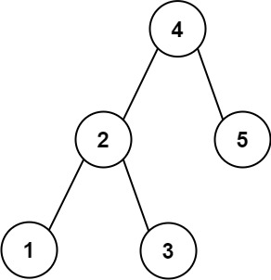

Input: root = [4,2,5,1,3], target = 3.714286, k = 2  
Output: [4,3]

**Example 2:**

Input: root = [1], target = 0.000000, k = 1  
Output: [1]

**Constraints:**

* The number of nodes in the tree is n.
* 1 <= k <= n <= 104.
* 0 <= Node.val <= 109
* -109 <= target <= 109

**Follow up:** Assume that the BST is balanced. Could you solve it in less than O(n) runtime (where n = total nodes)?